Software Requirements Specification

for

Gym Management System
Version 1.1 approved

Prepared by Team 16 -
Ronak M Surana
Prajwal Deshpande
Chatresh Ramasai Gudi
Nitesh Harsur
Prajwal Ambanna

11th September, 2026

Table of Contents

Table of Contents 2
Revision History 3
1. Introduction 4
1.1 Purpose 4
1.2 Intended Audience 4
1.3 Product Scope 4
1.4 References 4
2. Overall Description 4
2.1Product Perspective 4
2.2 Product Functions 4
2.3 User Classes and Characteristics 4
2.4 Operating Environment 4
2.5 Design and Implementation Constraints 4
2.6 Assumptions and Dependencies 4
3. External Interface Requirements 5
3.1 User Interfaces 5
3.2 Software Interfaces 5
3.3 Communications Interfaces 5
4. Analysis Models 5
5. System Features 6
5.1 Membership Management 6
5.2 Booking and Scheduling 6
5.3 Equipment Tracking 6
6. Other Nonfunctional Requirements 6
6.1 Performance Requirements 6
6.2 Safety Requirements 6
6.3 Security Requirements 7
6.4 Software Quality Attributes 7
6.5 Business Rules 7
7. Other Requirements 7
Appendix A: Glossary 7
Appendix B: Field Layouts 7
Appendix C: Requirement Traceability Matrix 8

Revision History
Name | Date | Reason For Changes | Version
All teammates | 11-09-2026 | Designed the initial SRS document. | 1.0
Ronak | 28-09-2026 | Added Security requirements, UML Use Case Diagram, IDs to Non Functional Requirements, updated RTM. | 1.1

1. Introduction

Purpose
This document specifies the software requirements for the Gym Management System, Version 1.0. It defines the scope of the entire application designed to handle memberships, bookings, and equipment tracking for gyms.

Intended Audience
The intended audience includes developers, project managers, testers, and documentation writers. The rest of this SRS contains the system features organized by module, non-functional requirements, and interface specifications.

Product Scope
The Gym Management System is a centralized web application that digitizes gym operations. It streamlines membership renewals, automates trainer and class scheduling, and tracks equipment maintenance lifecycles, directly reducing administrative overhead and improving customer retention.

References
IEEE 830-1998 Standard for Software Requirements Specifications.
SRS-Template.docx (Provided template)

2. Overall Description

Product Perspective
This is a new, self-contained web product. It replaces manual ledger-based tracking and disparate booking tools with a single unified MERN stack application.

Product Functions
Manage member registration, profiles, and subscription tiers.
Schedule and book group classes or personal trainer sessions.
Log equipment inventory and report maintenance issues.

User Classes and Characteristics
Admin/Manager: Highest privilege level, full access to revenue reports, user management, and system configuration.
Trainer/Staff: Moderate technical expertise; uses the system to manage their own schedules, view class rosters, and log equipment faults.
Member: Frequent users with varying technical expertise; uses the system to renew memberships and book classes.

Operating Environment
The software will operate as a web application accessible via modern web browsers (Chrome, Firefox, Safari). The backend will be hosted on Node.js/Express, utilizing a MongoDB database, with a frontend built in React using Vite and styled with Tailwind CSS.

Design and Implementation Constraints
Must utilize the MERN stack (MongoDB, Express, React, Node.js) as per project requirements.
Must enforce role-based access control (RBAC) securely.
NFR – 4: Passwords must be encrypted prior to database storage.

Assumptions and Dependencies
Assumes a stable internet connection for real-time booking updates.
Depends on a third-party payment gateway (e.g., Stripe/Razorpay) for processing membership fees

3. External Interface Requirements

User Interfaces
UI – 1: The UI will follow modern responsive design standards, ensuring compatibility across mobile and desktop displays. Standard navigation elements (Dashboard, Members, Bookings, Equipment) will appear on a persistent sidebar. Error messages will be displayed via standardized toast notifications.

Software Interfaces
The application will interface with a cloud-hosted MongoDB instance (e.g., MongoDB Atlas) to store user and operational data. It will also utilize RESTful API endpoints for internal communication between the React frontend and Node.js backend.

Communications Interfaces
NFR – 6: HTTP/HTTPS protocols will be used for all client-server communication. JSON format will be strictly utilized for message formatting and data transfer.

4. Analysis Models
Use case diagram identifying Admin, Trainer, and Member actors, alongside an Entity-Relationship Diagram (ERD) mapping Users, Subscriptions, Classes, and Equipment.

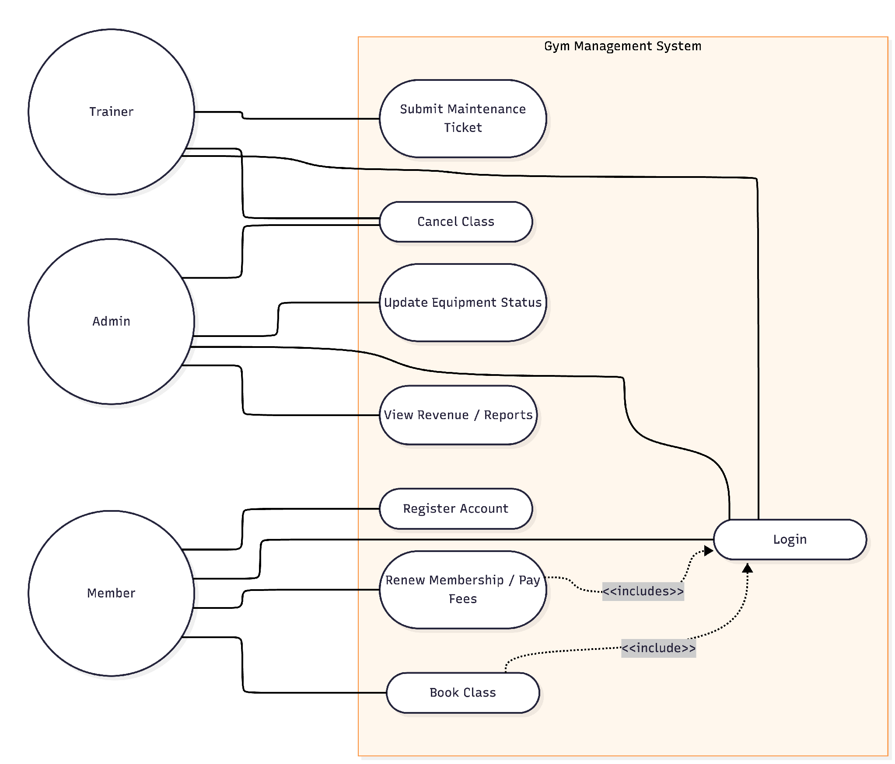

5. System Features

Membership Management
5.1.1 Description and Priority
High priority feature enabling registration, authentication, and subscription tracking.
5.1.2 Stimulus/Response Sequences
Member logs in -> Navigates to Subscription -> Clicks "Renew" -> System prompts for payment -> System updates expiry date upon success.
5.1.3 Functional Requirements
REQ-1: The system shall allow users to register with a unique email address and password.
REQ-2: The system shall automatically calculate and update the membership expiry date upon successful payment.

Booking and Scheduling
5.2.1 Description and Priority
High priority feature for managing facility capacity and trainer time.
5.2.2 Stimulus/Response Sequences
User selects "Yoga Class" -> System verifies available capacity -> User clicks "Book" -> System decrements available slots by 1 and confirms booking.
5.2.3 Functional Requirements
REQ-3: The system shall prevent a member from booking a class if the maximum capacity has been reached.
REQ-4: The system shall allow an Admin or Trainer to cancel a class, automatically notifying enrolled members.

Equipment Tracking
5.3.1 Description and Priority
Medium priority feature for facility maintenance.
5.3.2 Stimulus/Response Sequences
Trainer identifies broken treadmill -> Submits fault ticket -> Admin views ticket -> Admin marks status as "Under Maintenance".
5.3.3 Functional Requirements
REQ-5: The system shall allow staff to submit maintenance tickets for specific inventory IDs.
REQ-6: The system shall exclude equipment marked "Under Maintenance" from available use lists.

6. Other Nonfunctional Requirements

Performance Requirements
NFR – 1: API responses for dashboard data loads must resolve in under 1.5 seconds under normal load conditions.

Safety Requirements
NFR – 2: Database backups must occur daily to prevent loss of financial and member data.

Security Requirements
The system must enforce JWT (JSON Web Token) based user identity authentication. Admin routes must be strictly protected via backend middleware.

Security Objectives
Confidentiality: Ensure that all member personal data (e.g., passwords, contact details, and payment information) is protected from unauthorized access or disclosure.
Integrity: Guarantee that transaction records (e.g., membership payments and class bookings) cannot be maliciously altered by unauthorized users.

Security Requirements
REQ-SEC-01: The system shall enforce JWT (JSON Web Token) authentication for all API endpoints, requiring a valid token for any data retrieval or state change.
REQ-SEC-02: The system shall implement strict Role-Based Access Control (RBAC) on the backend, ensuring that only users with the "Admin" role can access the /api/users/delete or /api/revenue/view endpoints.

Software Quality Attributes
NFR – 3: The system prioritizes availability and reliability, ensuring members can access their digital entry passes 24/7.

Business Rules
NFR – 5: Only users with the "Admin" role can delete user accounts or alter financial records.

Appendix A: Glossary
MERN: MongoDB, Express.js, React, Node.js.
RBAC: Role-Based Access Control

Appendix B: Field Layouts
An Excel sheet containing field layouts and properties/attributes and report requirements.

Sample Member Registration Form Requirements
Field | Length | Data Type | Description | Is Mandatory
First Name | 50 | String | User's given name | Y
Last Name | 50 | String | User's family name | Y
Email | 100 | Alphanumeric | Unique login identifier | Y
Phone Number | 15 | Numeric | Contact number | Y
Password | 64 | String | Hashed authentication string | Y
Tier | 15 | String | Basic, Premium, VIP | Y

Sample Booking Report Requirements
Booking Report Fields
Booking Reference Number
Class Name
Member Name
Trainer Name
Booking Timestamp
Status (Active/Cancelled)

Appendix C: Requirement Traceability Matrix
Sl. No | Requirement ID | Brief Description of Requirement | Architecture Reference | Design Reference | Code File Reference | Test Case ID | System Test Case ID
1 | REQ-1 | User registration | Auth Module | Auth UI Mockup | authController.js | UT-01 | ST-01
2 | REQ-2 | Auto-update expiry on payment | Billing Module | Dashboard UI | paymentHandler.js | UT-02 | ST-01
3 | REQ-3 | Class capacity limit | Booking Module | Booking UI | classController.js | UT-03 | ST-02
4 | REQ-4 | Cancel class session & notify | Booking Module | Admin UI | classController.js | UT-04 | ST-02
5 | REQ-5 | Submit equipment ticket | Equipment Module | Inventory UI | ticketModel.js | UT-05 | ST-03
6 | REQ-6 | Out of order status hiding | Equipment Module | Inventory UI | equipmentRoute.js | UT-06 | ST-03
7 | REQ-SEC-01 | JWT Authentication enforcement | Security Arch. | API Spec | authController.js | IT-01 | ST-04
8 | REQ-SEC-02 | Role-Based Access Control | Security Arch. | API Spec | middleware.js | IT-02 | ST-05
9 | NFR-1 | Dashboard response time < 1.5s | Dashboard API | Performance Benchmark | dashboardController.js | TC-PERF-01 | ST-06
10 | NFR-2 | Daily database backup & restore | Backup Job / Database | Backup Recovery Spec | backupJob.js | TC-REL-01 | ST-07
11 | NFR-3 | 24/7 digital entry pass availability | Entry Pass Service | Member Pass UI | passController.js | TC-AVL-01 | ST-08
12 | NFR-4 | Pre-Storage Password hashing | Auth Module | Security Architecture | userModel.js | TC-SEC-03 | ST-04
13 | NFR-5 | Admin-only delete & financial changes | RBAC Middleware / Billing | Admin Console UI | roleMiddleware.js | TC-SEC-04 | ST-05
14 | NFR-6 | HTTPS and JSON communications | Express API Gateway | API & Network Protocol Spec | server.js | TC-SEC-05 | ST-09
15 | UI-1 | Responsive layout, sidebar & toast alerts | React Frontend Client | Responsive UI Wireframes | Sidebar.jsx / App.jsx | TC-UI-01 | ST-10

